Pronoun Subject

✅ What is Pronoun Subject
# Source: AI Source: Provided by: [Data Path: Persons Table -> ID Column: 1, Name_En Column: Motasem Essam] -> From: [Chatgpt (GPT-4-turbo)] on [8/4/2025]
A pronoun subject is a subject in the form of a pronoun—a word that takes the place of a noun and performs the action of the verb or is described by it.

🔹 Key Features:
# Source: AI Source: Provided by: [Data Path: Persons Table -> ID Column: 1, Name_En Column: Motasem Essam] -> From: [Chatgpt (GPT-4-turbo)] on [8/4/2025]
- Stands in place of a noun.
- Can refer to people, things, places, or ideas.
- Must agree with the verb in number and person.

🔹 Common Subject Pronouns:
# Source: AI Source: Provided by: [Data Path: Persons Table -> ID Column: 1, Name_En Column: Motasem Essam] -> From: [Chatgpt (GPT-4-turbo)] on [8/4/2025]
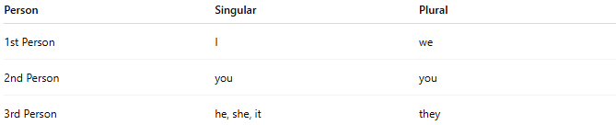
Person | Singular | Plural
1st Person | I | we
2nd Person | you | you
3rd Person | he, she, it | they

🔹 Examples:
# Source: AI Source: Provided by: [Data Path: Persons Table -> ID Column: 1, Name_En Column: Motasem Essam] -> From: [Chatgpt (GPT-4-turbo)] on [8/4/2025]
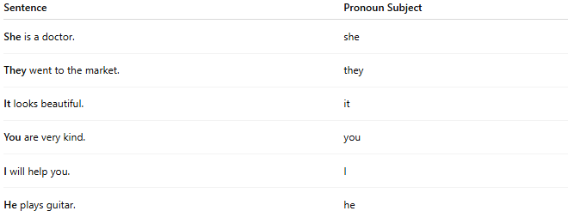
Sentence | Pronoun Subject
She is a doctor. | she
They went to the market. | they
It looks beautiful. | it
You are very kind. | you
I will help you. | I
He plays guitar. | he

🔍 Usage Notes:
# Source: AI Source: Provided by: [Data Path: Persons Table -> ID Column: 1, Name_En Column: Motasem Essam] -> From: [Chatgpt (GPT-4-turbo)] on [8/4/2025]
- Pronoun subjects are often used for clarity, brevity, or when the noun has already been mentioned.
- In formal grammar, they always function as subjects, unlike object pronouns (me, him, them, etc.).

